🧑‍💻 Mission: Bits Battle - Guidelines
Welcome to Mission: Bits Battle! This is a Capture the Flag (CTF) Challenge.
Your mission? Find hidden codes ("flags") hidden within challenges that test your programming skills, web development know-how, and data science expertise.

💡 How It Works:
- There are 8 problems, each requiring you to think outside the box.
- Flags are hidden in files given to you. They might be hidden in encrypted messages, images, websites, or data patterns. Use your technical skills and a bit of hacker mindset to uncover them.

🏆 Race to the Top:
- The leaderboard will keep track of your scores. The first person to solve the most challenges wins!
- You have 90 minutes for this mission, so manage your time wisely!

🚨 To keep the competition integrity, sharing answers between teams is strictly prohibited.

🎯Overview of the problems
There are 3 levels of difficulty for the problems, solving each will give you different scores:
🟢 Easy - 100 Points
🟡 Medium - 150 Points
🔴 Hard - 200 Points
The flag will be displayed as text and may include uppercase and lowercase letters, symbols, and numbers. However, it will always form recognizable words or phrases. The string length of the flags are also provided here.
 | Problem | Difficulty | Theme | Hint | Length
1 | Monkeys | Easy | Image Processing | “Spot the difference” | 9
2 | Audio | Easy | Audio Signal Processing | “Look at the sound” | 5
3 | Simple Web | Easy | Web Development | “You won’t need one 😭” | 19
4 | NPY | Medium | Numpy Array | “Square” | 8
5 | Flag Button | Medium | Web Development | “HTTP” | 18
6 | Bin | Medium | Bits Operation | “Exclusive Or” | 9
7 | Harry Potter | Hard | Image Processing | “Sometimes, the least significant bit carries the most meaning.” | 8
8 | CSV | Hard | Data Science Techniques | “Too many dimensions?” | 5
* The difficulty levels are subjective—so don’t let the rating discourage you!

🚩 Submission Guideline

- Submit the flags via https://flag-submission.onrender.com
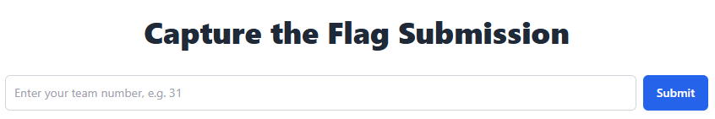
- Enter your {team number} to access the submission boxes and leaderboard.
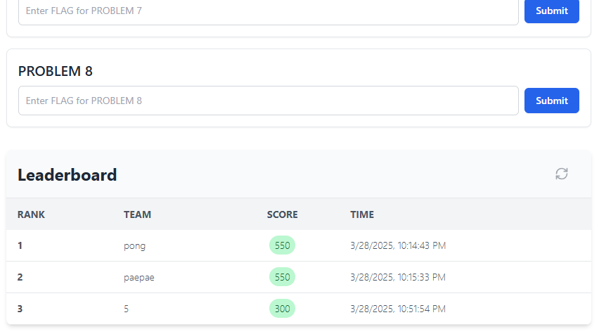
- The ranking is ranked by the total score. If two teams have the same score, the team submitting their last correct answer first will be ranked higher.

📝 Reloading the page will require you to re-enter your team number. Please make sure you fill in correctly.

